|  |
| --- |
| COS30045 DATA VISUALISATION |
| VISUALISATION PROJECT |
| REFLECTION |

|  |
| --- |
| RUBIE STANNARD: 103982732  1567 WORDS |

**Table of Contents**

1. Introduction 2
   1. Week 1 to Week 7 2
   2. Week 8 to Week 11 3
   3. Week 12 4
   4. Week 13 5

Conclusion 6

## **Introduction**

Throughout the completion of this unit, and with the help of my partner Dilni De Silva, and my class teacher Shalmoly Mondal who I saw every Monday at 12:30 pm, I learnt a lot of data visualisation and programming concepts. By completing the lab exercises we had each week and progressing with our visualization project, I learnt about Tufte’s Data-Ink Ratios, JavaScript, D3, CSV files, GeoJSONs, and more skills and knowledge needed to create an interactive data visualization. I have my teacher Shalmoly and my partner Dilni to thank since they both helped when it was needed and taught me a lot of new things. Throughout this semester, I had no teamwork issues with Dilni whatsoever.

## **Week 1 to Week 7**

In the first week of the unit, I paired up with another student named Dilni De Silva. She approached me and asked if I wanted to work with her, so I agreed. We immediately organised a meeting time, which was 6:00 pm every Friday, and started planning out each week by creating a timetable.

We set up a Google Drive and made folders and files for everything we needed, like a document for each page of the project process booklet, and a GitHub repository. After this, we came up with our topic about migration/immigration related to law and order and began our research.

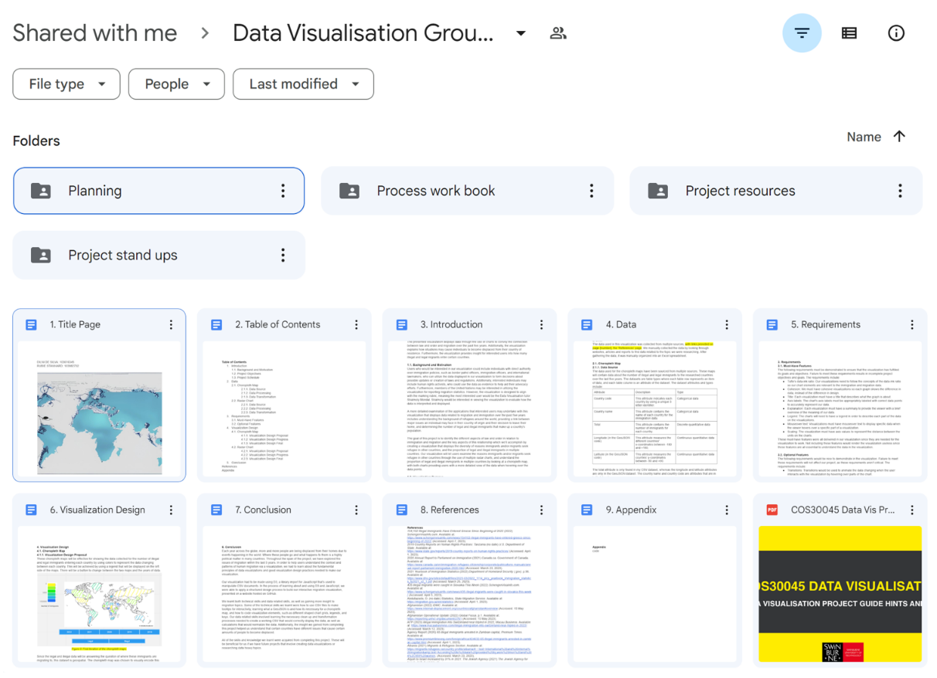

*Figure 1: Google Drive project documents.*

Nothing much happened in week 2 and 3 as we were still collecting data, finalising the timetable, and finalising the research questions. As well as working on different part of the project, we had to complete lab exercises and lab exercise demonstrations.

In week 4 we had our first project stand up where we discussed our overall project plan with Shalmoly, told her what we had done so far, and got some feedback about the types of graphs we should use for the data we had, as well as some clarification on things we were unsure about.

We had a visualisation analysis assignment in week 5, so we didn’t do much on the project while we were getting the assignment done. During this week, while we were doing our visualization analysis assignment, after discussing the feedback we got from Shalmoly in the project stand up the previous week, we finalised the graph types and created two wireframe iterations of them. We also decided to create a wireframe iteration of the website so we had a rough idea of what it would look like and so we could easily make changes to it if we needed before we started coding.

Week 6 is when we started the major parts of the project process booklet, the visualisation design, and data sections. Because I had already collected my data, I set up the subheadings for each of these sections, put some of the images we had in, and started writing whatever I could. By the end of week 7, the biggest part of the project we completed was the requirements section of the project process booklet, and the collection of my datasets.

## **Week 8 to Week 11**

By week 8 I had already organised my data into Excel tables, ready to be converted into CSV files. Week 9 is when the website coding started. I set up a HTML page for each chart, a JavaScript folder with a JavaScript file for each visualisation, and a CSS folder and files. At this point, the only page that was completed was the home page. Because we had multiple visualisations, we decided to add a home page as the place to start on the website. Users could then navigate to each visualisation.

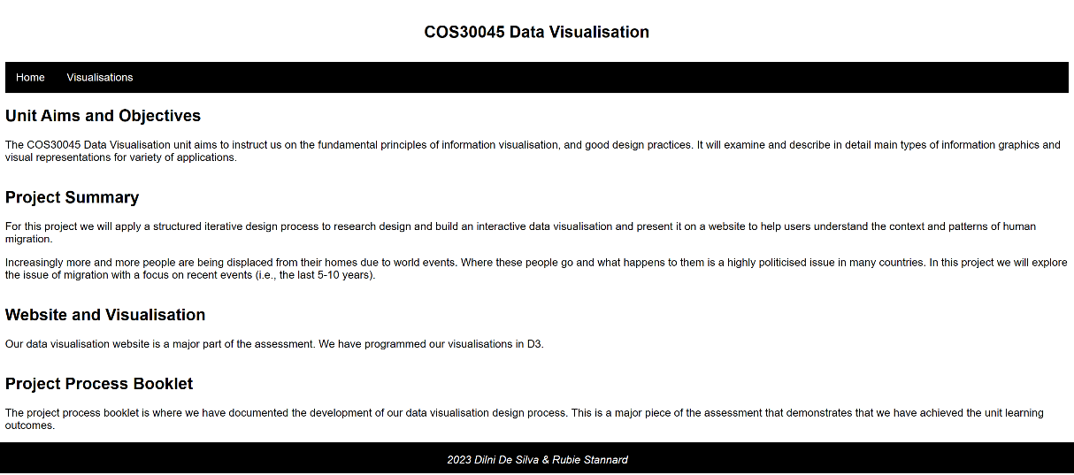

*Figure 2: Website home page.*

We had another project stand up in week 10, with this one being about the data and design. We showed Shalmoly our progress, which wasn’t a lot as we only started coding, and the only code completed as the home page. The main work we had to show were the graph iterations and some data tables. This week was when we also completed the introduction section for the project process booklet.

There was another project stand up in week 11. We had to show our further progression with the data and visualisation design since the last stand up and show where we were up to with the code. Because we still hadn’t started coding, and only I had finished collecting my data, there still wasn’t much to show, but Shalmoly gave us good feedback with the limited evidence we had and gave us some suggestions about where to find some code and general advice about ways to catch up again.

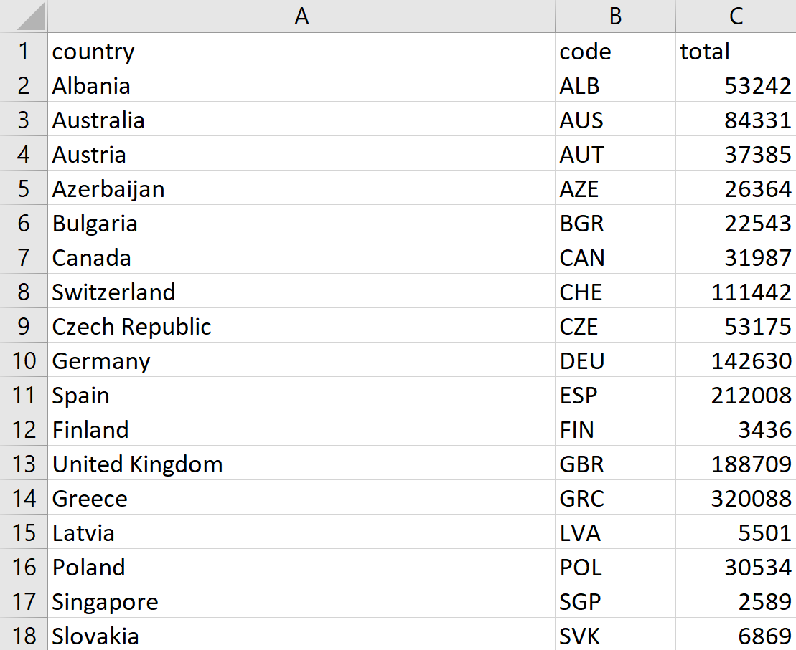

*Figure 3: My datasets in week 11.*

The datasets I had by week 11 were two Excel spreadsheets, one for the legal data and one for the illegal data, so both of the spreadsheets looked like Figure 3. Since I was a bit unsure how to code the choropleth maps, I still hadn’t started, so I kept doing whatever work I could with the website and process booklet. I referenced all of the sources we used and ended up completing references section of the project process booklet.

## **Week 12**

We had the last class and the final project stand up where we showed Shalmoly everything we had done far and asked for feedback. A major part of this stand up was asking Shalmoly what we could do to make Dilni’s data work since she had big values. She changed the data to normalised values, which Shalmoly said was fine. We also let her know that we had to divide some of the values to get enough data for the huma trafficking radar chart reason.

Dilni finished collecting her data, so on Friday we started coding. By this time, we had completed multiple sections of the project process booklet, including the conclusion, data section and visualisation section. We had started the appendix as well, managing to complete some of it.

At the end of week 12 I had coded the choropleth maps for my immigration data. The choropleth maps only show on the Microsoft Edge website when the Live Server extension on Visual Studio Code is used to Go Live.

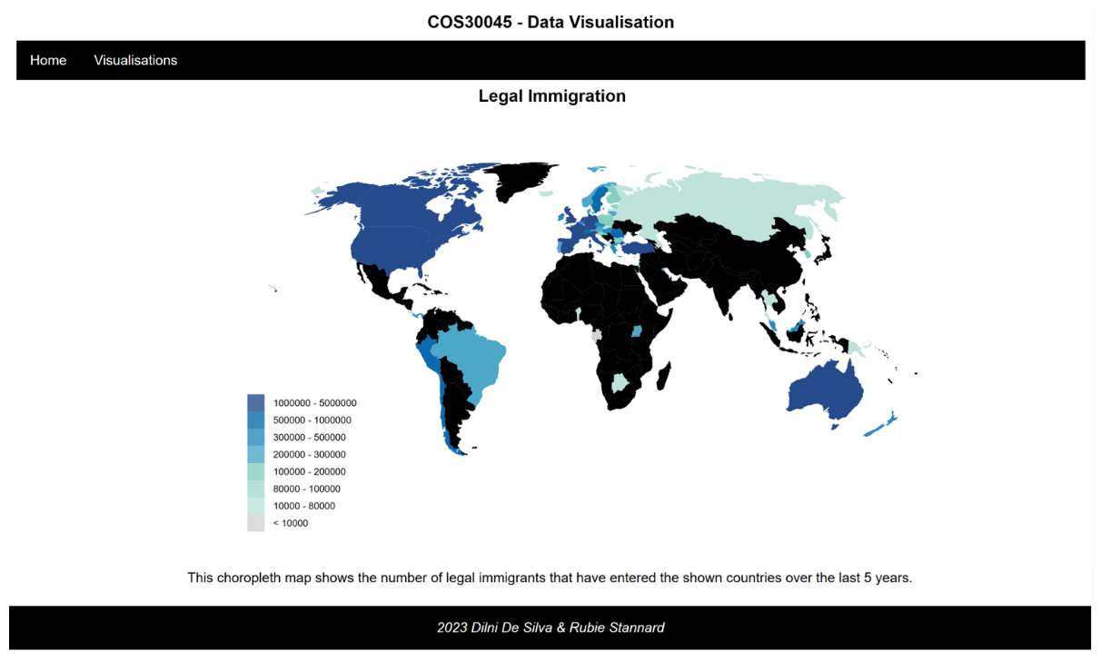

*Figure 4: Choropleth map.*

While I was coding the choropleth maps, the only trouble I had was figuring out how to change the fill colour from black to grey for the countries that had no data, and change what the tooltip displays. I wanted to change the tooltip text from saying “undefined” to “no data,” but I couldn’t find the part of code that changed this or the fill colour. These are on the final visualisation.

## **Week 13**

This week Dilni completed her radar chart code, meaning the website was complete as was the appendix section of the project process booklet. On Sunday the 4th of June I submitted the project process booklet and the website as a zip folder, as well as the individual project and group reflection.

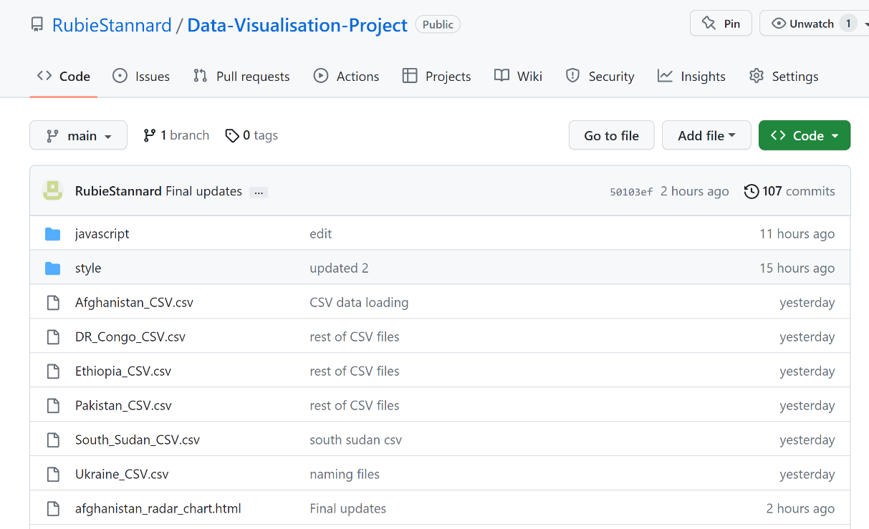

*Figure 5: GitHub repository.*

Although the project process booklet asked for a Mercury server link, we were having problems with WinSCP. We told Shalmoly about this early in the semester, and she said it was alright to use our GitHub link instead.

Admittedly, week 13 was a crunch week where we did most of the coding work. This wasn’t ideal as we had unfinished code that could’ve been finished if we had more time. We addressed all of this in our project process booklet and on the website, so the teacher knows what we were planning to do but didn’t do even though we had a lot of data left.

One thing we put on the website to let the teacher know we were planning on incorporating a tooltip for the radar charts was a table that had the data for each reason, for each year. We wrote that this would’ve been the data to appear if a tooltip was implemented. Aside from this, we left code in for the tooltip as another way to display what we had been planning.

## **Conclusion**

Overall, the only issue I faced was being ahead of Dilni in terms of data collecting and coding. This wasn’t a big problem for me since I just went ahead and coded the website so we had a layout and pages for everything and went through the project process book to write whatever I could to help us catch up and finish on time. I really didn’t mind this because I was also behind, and both of us were still doing work. I preferred going through and doing all that I could and setting up the website, and I knew Dilni appreciated it since she was busy with her capstone project, and this took some pressure off of her.

This unit taught me the fundamentals of designing visualizations and the design principles. Although I had a lot of issues with the code not working, I feel like I was able to demonstrate that I was progressing each time I completed an exercise, and by completing the visualisation, I demonstrated that I learnt what this unit was teaching us.

Before this unit I had completed COS10005 Web Development, so I had some experience with HTML and CSS, but little with JavaScript. The only coding software I had used was Notepad++. If I was to do another coding unit, Visual Studio Code would be the software I would want to use. After completing the COS30045 Data Visualisation unit, I feel like I’m better at designing visualizations and analysing them.